An Exploratory Analysis of AI Usage and Academic Performance



A FINAL PROJECT REPORT
STAT 112
INTRODUCTION TO DATA PROCESSING AND VISUALIZATION
DEPARTMENT OF STATISTICS OF
MIDDLE EAST TECHNICAL UNIVERSITY

BY

Sema Güngör
Cevahir Avcı
Utku Şener
Tuana Özel
Yusuf Said Öztürk

1.ABSTRACT:

Artificial intelligence has been becoming an important part of our lives, especially it has huge impact in education world. This project aims to examine how AI affects academic performance such as GPA, exam scores and assignments. After data cleaning and tidying steps, research questions are created and visualized via graphs by using cleaned dataset. These questions are based on the duration and frequency of AI usage and shown relationships with academic performance from different study levels or majors. As a result, the graphs are interpreted.

2.INTRODUCTION:
Artificial intelligence (AI) tools are increasingly used by university students for studying, completing assignments, and preparing for exams. Tools such as writing assistants, problem-solving systems, and concept explanation applications have become part of students’ learning practices across various academic fields. As the use of these tools continues to grow, it becomes important to examine how AI usage relates to students’ academic performance. This study also focuses on this relationship.
However, the direction of the relationship between AI use and academic achievement is still debated. Current observations indicate that the use of AI does not always increase academic performance linearly. While AI-supported study methods may improve efficiency for some students, their impact can remain limited in other cases. Moreover, academic success is not solely reflected by exam scores, but also includes factors such as assignment completion, study habits, and overall academic consistency. As a result, the effect of AI use may differ depending on the academic discipline.
In this study, a dataset of university students is analyzed using exploratory data analysis (EDA) to examine the relationship between AI usage frequency and several indicators of academic performance. Visualizations based on exam scores, grade point average (GPA), and assignment completion rates are used to explore how AI use varies across different academic contexts. The primary aim of our study is not to make causal claims, but rather to present meaningful observations regarding the relationship between the use of artificial intelligence and academic performance.
3. DATA SET INFORMATION:
The dataset used in this study is “students_ai_usage_synthetic_1600_DIRTY”, containing information about ai usage such as frequency of usage, how many hours spent per week using ai and primary usage for ai, academic performance such as how many hours studying per week, attendance rate, assignment completion rate, exam scores and GPAs of students lastly demographics information about students like gender, study level and major. Dataset contains over 1600 observations and 13 columns. The original dataset was dirty featuring missing values, duplications, and misspellings. Dataset transformed to tidy format using python where each row is an observation and each column is a unique variable to use in accurate statistical analysis and visualization.
4. DATA TIDYING AND CLEANING STEPS:
- Data examined for their variable types. Dataset contains 13 columns, 6 of them are numerical and 7 of them are categorical data.
- Dataset imported to idle with separation mark “;” checked for head and tail. Dataset contained NAs and header for rows and column names for columns.
- Dataset checked for tidiness; columns headers are variable names, only one variable stored in each row and column. Single observation units are not stored in multiple tables. Datasets don’t need tidying techniques.
- Column names contain typos. They are fixed using strip and replace methods. Strip method for getting rid of blank spaces, lower for lower case letters and replace for replacing “__” with “_”.
- Dataset doesn’t contain unnecessary columns.
- Dataset checked for duplicates with duplicated().any(), detected duplicates removed with drop_duplicates().
- Data types examined Study hours week column had wrong data type.
- In numerical values “,” replaced with “.” Using a for loop for numerical columns, type of study hours week column corrected in this loop also. In categorical values with help of a for loop each value changed to format of lower-case letter removed symbols and blank spaces.
- Categorical values checked for value counts. Misspelling corrected using replace method.
- Numerical columns were in correct range.
- Numerical values check for outliners using IQR method with help of a for loop. Detected outliners changed to mean of their column.
- Dataset searched for uniformity.
- Dataset checked for missing values using isnull method. Missing numerical values replaced with median of their column and categorical ones replaced with their mode.
5. EXPLORATORY DATA ANALYSIS:
Research Question 1 – Yusuf Said Öztürk
Does average exam score differ across AI usage frequency groups?

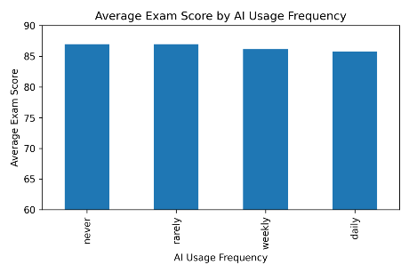
Figure 1. Bar Chart of Average Exam Score by AI usage Frequency

Figure 1 investigates whether average exam scores differ across AI usage frequency groups. To address this question, a bar chart was created to compare the mean exam scores of students who report different levels of AI usage frequency. The visualization shows that average exam scores across the groups are very close to each other. While slight differences can be observed, there is no clear separation between groups.
To make these small differences easier to see, the y-axis of the bar chart was restricted to the range of 60 to 90. This adjustment was made only to improve visual readability and does not change the underlying data. Overall, the results suggest that AI usage frequency alone does not have a strong association with exam performance, and any observed differences in average scores are relatively minor.

Research Question 2 – Cevahir Avcı
Does the frequency of AI use have an effect of students’ homework completion rates?
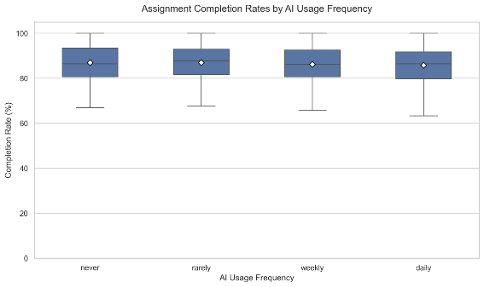

Figure 2. Box Plot of Assignment Completion Rates by AI usage Frequency

According to Figure 2, the frequency of AI use has a very small effect on students’ homework completion rates. The fact that the median values between the groups are very close indicates that the frequency of AI use does not have significant effect on homework completion. Another striking thing in this graph is that students who use AI very little complete their homework more frequently. In short, we can say that AI has a very small effect on homework completion. This may be due to students generally using AI infrequently, or AI being inadequate in this regard, or something else; we cannot deduce this entirely from this graph. We would need different graphs to understand this better.

Research Question 3 – Tuana Özel
How does the relationship between weekly AI usage and GPA differ across study levels?
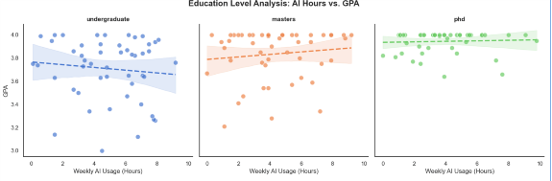

Figure 3. Scatter plots of GPA vs. AI usage for across study levels
Figure 3 demonstrates the relationship between AI usage and GPA across three study levels: undergraduate, master’s, PhD. First, when we observe dataset, number of students in each study level is different from each other (1261 students are in undergraduate level, but just 57 students are in PhD), so we take equal sample size(n=50) from each category. In that way, we used a balanced sample for each level. Additionally, The tube-shaped (Confidence Interval) around the regression line. For showing uncertainty levels in the estimated correlation between weekly AI usage and GPA.
For undergraduate students in first plot, when weekly AI usages for academics are increasing, unlike GPA does not tend to increase. In contrast, regression line indicates that high AI usage is not beneficial for academic success (GPA). Thus, in undergraduate level, we understand that it cannot always be said that using AI improves GPA. Then, as seen in second plot, applying AI tools enhance GPA between master groups unlike undergraduate. Also, same observation can be seen in PhD level. Compared to master level, the slope of regression line in PhD is relatively low, but we can state that there is a slightly positive correlation between them. In other words, the near-horizontal regression line illustrates that benefits of AI tools have little observable association with academic success at doctoral level.
Finally, these patterns show relationship between usage of AI tools for academics and GPA across different study levels. In each level, we can see distinct observations, and we can understand that even for academic purposes, AI does not guarantee higher GPA.

Research Question 4 – Sema Güngör
Does the association between AI usage frequency and exam performance vary across academic majors?
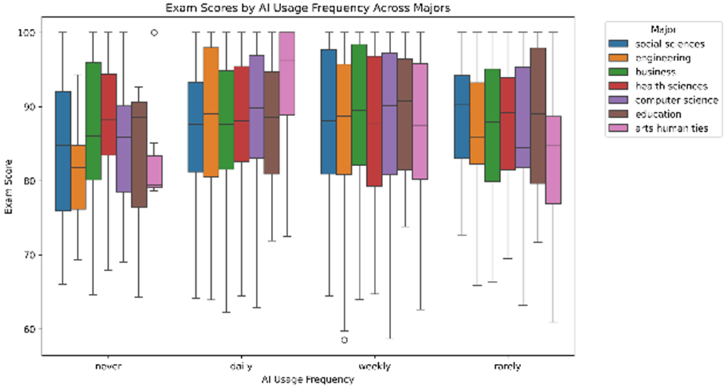

Figure 4. Box plots of Exam Scores by AI usage Frequency across majors
Figure 4 compares the distribution of exam scores based on the frequency of AI use among students across different departments. AI usage frequency was examined at four levels, and corresponding exam scores were analyzed across seven departments. The relationship between AI usage frequency and exam success is observed to differ between departments. While in some departments the median exam score increases as the frequency of AI use increases, in others this relationship is negligible and weak. In particular, in technical fields such as engineering, computer science, or arts humanities, students who use AI more frequently have higher median exam scores compared to students who use it less frequently or not at all, suggesting that the impact of AI use on academic success may be stronger in these fields. On the other hand, in fields such as education, health sciences, or social sciences, the use of AI has a more limited and insignificant effect on exam success.
Therefore, we cannot directly conclude that the use of AI increases academic success. When examining the impact of AI use on academic success, the departments to which the students belong should also be considered.

Research Question 5 – Utku Şener
How does AI usage (Never, Daily) affect GPA across majors?
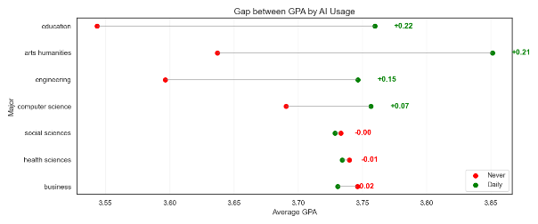

Figure 5. Dumbbell plot of GPA by AI Usage
Figure 5 visualizes the relationship between AI Usage and GPA across majors. AI usage is filtered by daily usage and did not use at all. Graph is a dumbbell plot which its y-axis is majors and x-axis is average GPA. Red dots are average GPA of students that don’t use AI and green dots are average GPAs of students which use AI daily.
AI usage doesn’t improve GPA at all majors. Education and arts humanities show most dramatic increases. Education has positive 0.22 and art humanities has 0.21 increase. The graph shows students who never use AI in education major have lowest average GPA in entire dataset. Technical fields are also affected by AI usage. Engineering students who use AI have 0.15 more GPA score than non-users. Computer science has less but it is affected positive with 0.07 points. Social sciences weren’t affected by AI either AI users or non-users have same GPA score. Health sciences and business have negative scores but difference between GPAs of AI users and non-users is very low. Health sciences have negative 0.01 difference and business has 0.02 negative difference. This slightly negative effect on health sciences and business could be because these majors need more theoretical and real-world study methods. In tech fields using AI has meaningful differences. AI can be big parts of these fields. Education and art humanities fields usually involve heavy amounts of reading and writing practices. AI could help with better writing and save reading time for students.

6. CONCLUSION
This study investigated the relationship between the frequency of students' use of Artificial Intelligence and key academic outcomes such as grade point average, exam scores, assignment completion. The results indicate a marginal relationship between AI and academic achievement. The data showed notable similarities across different usage groups suggesting that AI use is not the most important factor in student success. Rather, academic outcomes appear to be influenced by other parametres. It is important to acknowledge the limitations of these findings based on data; therefore, broader research is needed to fully understand the impact of AI on education.

Github link:

